Changes in the Esp21 light IoT

1. The battery pins (positive and negative) are inverted

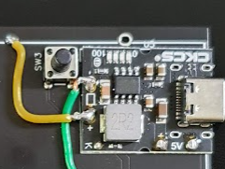

1. The 8x8 LEDs module doesn’t fit nicely on the board (Pins don’t connect too)

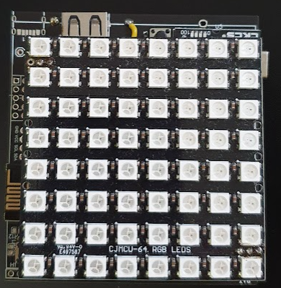

1. When the 8x8 module is place, there is not easy access to turn on/off switch

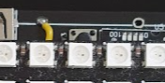

1. Some components name are not clear

